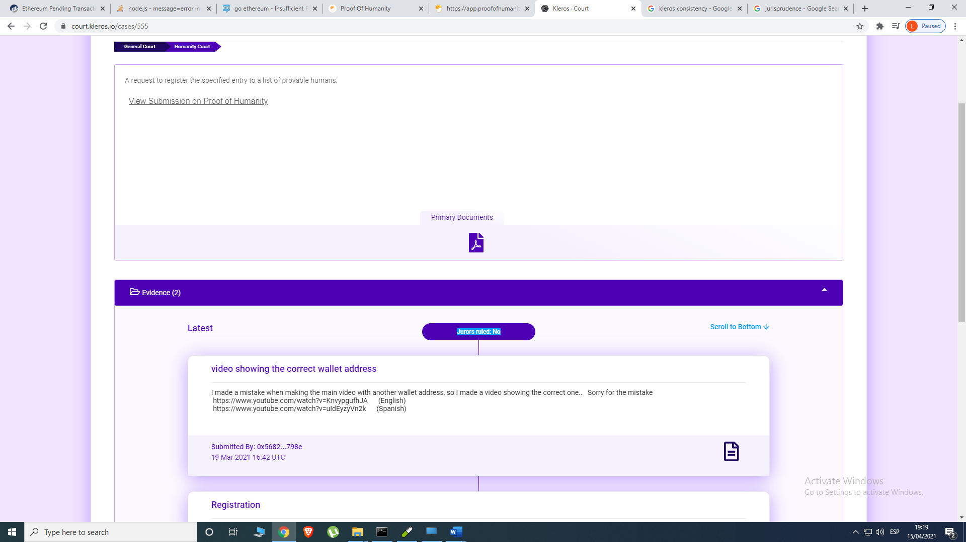
https://court.kleros.io/cases/555

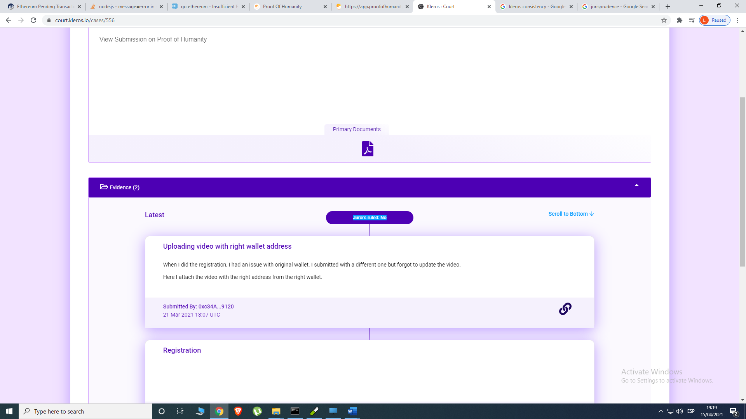
https://court.kleros.io/cases/556

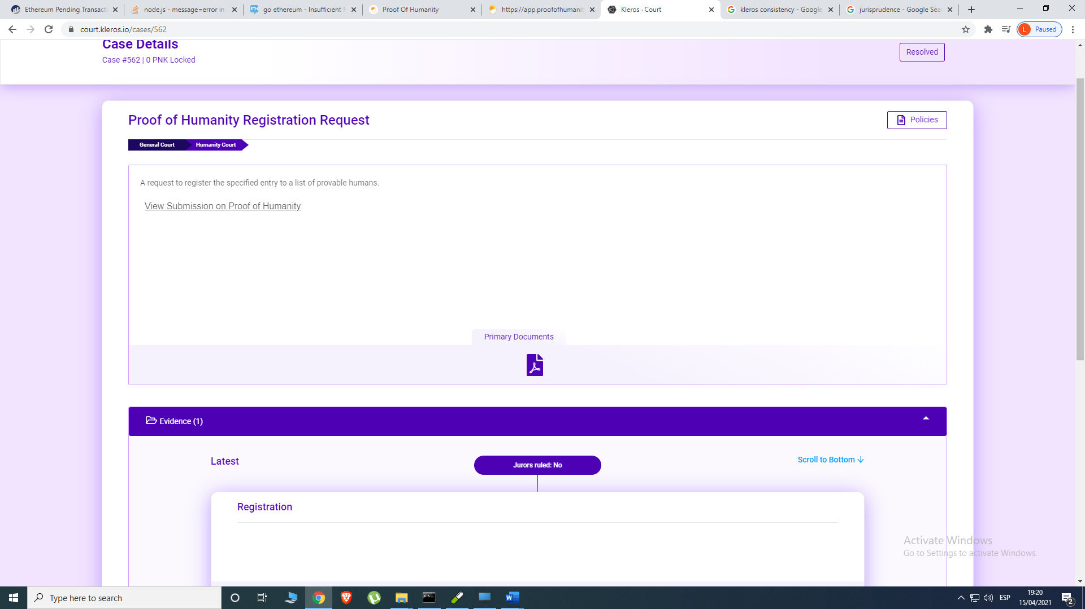
https://court.kleros.io/cases/562
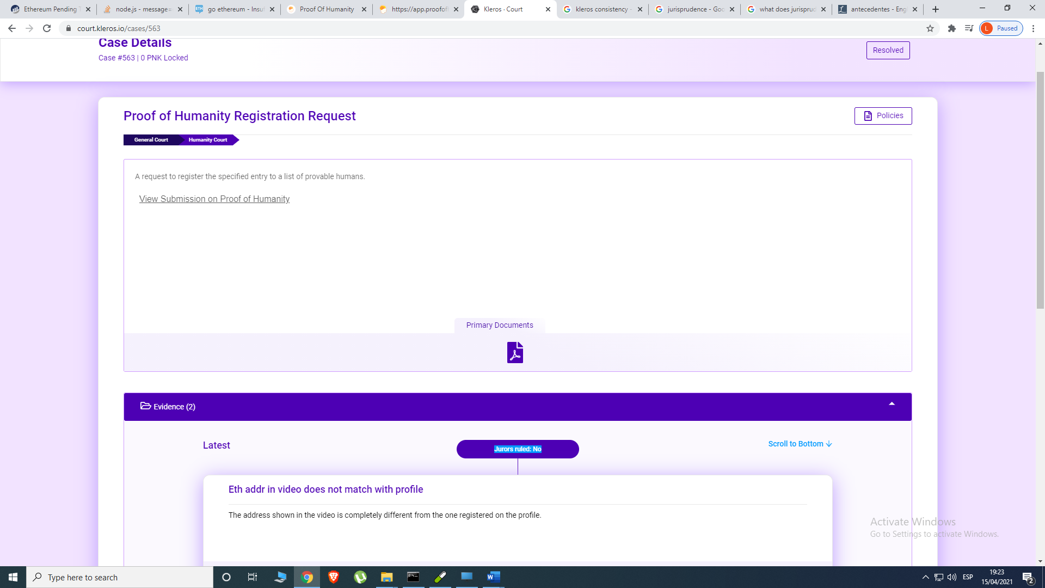
https://court.kleros.io/cases/563

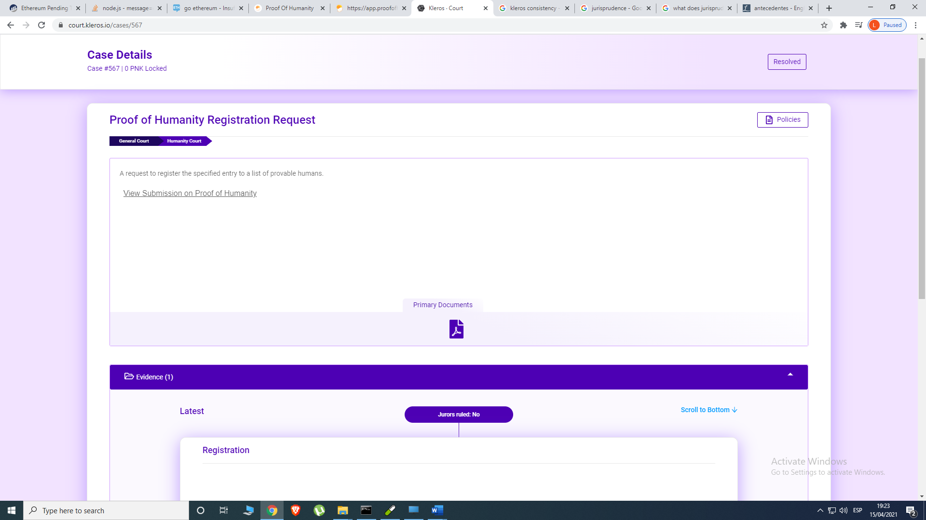
https://court.kleros.io/cases/567

