Defense of dispute#779
The challenger submitted a wrong challenge justification. When I proved the challenger that the address was readable, moved its point to something else that is completely subjective to the challenger.
Challenge justification: Ethereum address not visible
“Unfortunately, the ethereum address is not readable, therefore, the profile should not be accepted”
This was already explained in one of the uploaded evidences:
“Although it is brief, the Ethereum address appears in the video at 0:10. It is viewable both in the browser's navigation bar but also on top of the QR code. Check the picture.”
Evidence #2: Insufficient lighting conditions
“This video violates rule #4. Lighting conditions should be sufficient to discern facial features. Also, the face of the submitter in the video should follow the requirements of section 2. It is not possible to identify his eyes nor a great part of the face as required due to poor lighting conditions”
In order to prove that the challenger is wrong we have used facial detector IA and as we can see below the AI easily recognize facial features
Evidence 1: Using video AI recognition (https://scanner.deepware.ai/)
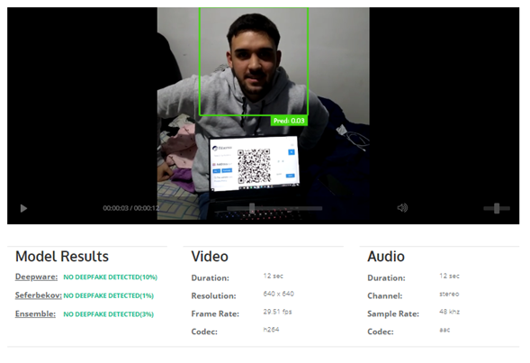
Evidence 2: Using a screenshot of the video with a photo IA recognition (https://betaface.com/)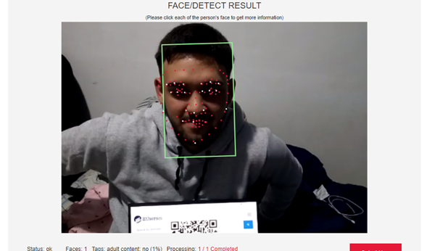

I want to point out again that sufficient lighting condition is something subjective for humans, but not for AI tools that can detect faces pretty good.
So hereby I (and AI tools) certify I am a real human, thank you.

