Dear jurors:
I’d like to start my defense for Bety, by saying that the challenger claims that the submission broke the policy #2 of the Proof of Humanity submission guidelines. I don’t believe that is accurate. The policy states the following: “Face should not be covered under heavy make-up, large piercings or masks hindering the visibility of facial features. Headcover not covering the internal region of the face is acceptable (For example, a hijab is acceptable for a submitter but a niqab is not). - It can include items worn daily (ex: headscarf, turban, wig, light makeup, etc) provided they do not violate the previous point. It cannot include special items worn only on special occasions that can, voluntarily or involuntarily, distract humans or algorithms from being able to detect identical faces.”
In Bety Caballero’s case, I don’t think we could call the bandage on her nose something that she wears on a special occasion, but something that she MUST wear everyday due to a medical condition.
On the other hand, the challenger states that the submission is in violation of policy #4, which says the following: “Lighting conditions and recording device quality should be sufficient to discern facial features and characters composing the Ethereum address displayed.”
The Ethereum address is easily distinguishable, and the face of the submitter is too.
To literally bring some light on this matter, I ran the image uploaded by Bety and a screenshot of the video on a Facial recognition tool provided by Microsoft. The output has two parts: first, it tells you if the system believes that both images are indeed from the same person, and then a level of confidence on the result provided.
This is the result, so you can see it for yourselves:
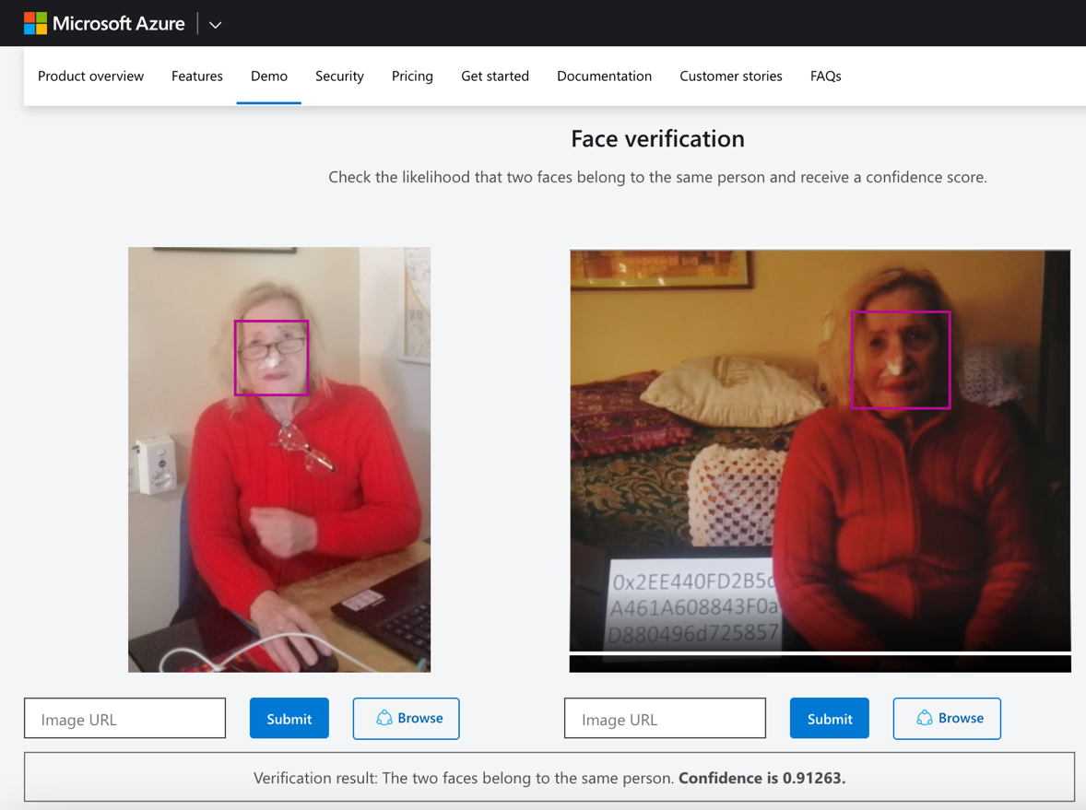

I think a 91.2% confidence result is far enough to assume the lighting on Bety’s environment and the bandage she need to use are enough to be able to differentiate her facial features and assume that she is a real human.
In the end, all the submission policies are in place to ensure that both photo and video can be used so that an algorithm can recognize faces. I think it’s crystal clear that algorithm such as Microsoft’s are able to identify the submitter and that doesn’t present any threat to the registry’s safety.
Given that the challenger didn’t provide any other substantial evidence or precedent of case law, the vote on the dispute should be to proceed accepting the submission.
Thank you all for your kind attention and time.

