Delfina`s Case

Incorrect submission. The video don´t have at least 360p.
Video quality can be evaluated objectively by mathematics or subjectively by human observers (the latter is less accurate than the former). Few key concepts to get familiar with video quality parameters.

Pixel:

A pixel is the minuscule fragment of an image or display that a computer can print or display. If you zoom in an image, it will appear like a mosaic pattern by small tiles, and this is a pixel. This concept of the pixel is true in digital imaging so a pixel is the smallest addressable element of a picture. As we know, an atom is the smallest unit of matter, in the same way, a pixel is the smallest unit of an image.

Resolution:

Resolution is the number of distinct pixels in an image. A high-resolution image will have more dots, which allows it to display more detail. Resolution generally refers to monitors, printers, and bit-mapped graphic images. It is usually denoted as width × height and the units in pixels.

For instance, 1024×768p, 1024 indicates the width and 768 indicates the height of display in pixels. The pixel resolution determines the quality-more pixels per inch of the monitor screen gives better image results. A display with a resolution of 1024x768p will yield 786,432 pixels on the screen.

Understanding resolution by examples and numbers:

A 640x360p video is formed by 360 lines and each line is 640 pixels wide. So, it can be said that a 360p video has a resolution of 640×360 pixels = 230,400 pixels.
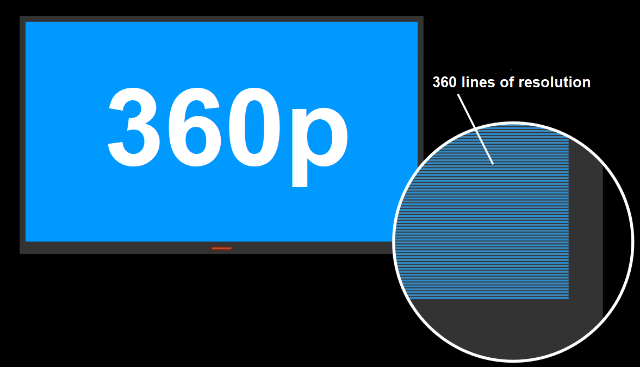

In contrast, a 640x352p video has 352 lines which and 640 pixels wide. So, it can be said that a 352p video has a resolution of 640×352 pixels = 225,280 pixels.

In this case, the video of submitter has 640x352p resolution. You can download the video and see the technical specifications on your own to verify this:

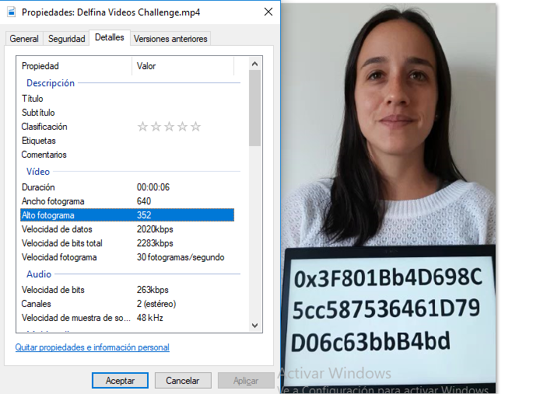

Where the word "Alto Fotograma" appears shows that the video has 352p lines, so it does not reach the 360p required by the rule # 4 of Proof of Humanity registry policy.

Precedent cases:
As set precedent by case #667, the video resolution with 352p is lower than the required 360p.

The 3 jurors vote NOT to accept the registration.

Also in cases #673 and #674 all the jurors (6) voted NOT to accept the submitter's registration because the resolution did not reach the required 360p. In this cases, also the resolution was 352p.

In adderance, in the case # 615, where the video resolution was 352p, one of the jurors sentenced the following:

"Furthermore, the video does not reach the 360p required in one of the dimensions."

Some considerations:
The goal of the challenger is to make those who upload a profile to POH comply with the established rules.
For a challenger to waste time and resources looking for profiles that do not comply with the POH rules, they must have an economic incentive. Otherwise no one would do that job and we couldn't have a curated list of humans resistant to sybil attacks.

This is not an advantage for the challenger. It is an incentive for the entire community to collaborate in strengthening the system by finding profiles that do not comply with the rules.
The spirit of the project is to generate a curated list of humans meeting a minimum number of requirements.
There are submitters who do not follow the rules, adduce to be human and say that they should be accepted (they do not reach 2% of the submitters). For this to be possible, it would be necessary to modify the rules and establish that no requirements are needed to be accepted.
On the other hand, are the rest of the 98% of submitters that prepare their profile, check that it complies with all the required rules, then they upload their profile and they are accepted without problems. It is not that complicated if you are a human.
Some may pose technical impossibilities to do so. The truth is that it´s not impossible to make a video with a resolution equal to or greater than 360p. In fact, 98% of submitters have done so.
This is the way that the POH system regulates itself to meet its objective and at the same time strengthening the system by enforcing its rules.

In Conclusion:
- 230,400 pixels is not the same as 225,280 pixels,
- And therefore 352p is not the same as 360p.

The submitted video is 352p which is lower than the required 360p and this submission violates the rule #4 of Proof of Humanity registry policy.

Rule #4. Video of the submitter displaying a sign with his Ethereum address – Required The video quality should be at least 360p, at most 2 minutes long, and in the video/webm, video/MP4, video/avi or video/mov format. Lighting conditions and recording device quality should be sufficient to discern facial features and characters composing the Ethereum address displayed.

Link: https://ipfs.kleros.io/ipfs/Qmc7ag5XohnSAozvsKsLCUbvaFyasyLtyi3H7g3mmxznPU/pr oof-of-humanity-registry-policy.pdf

As long as the rules say 360p and it is not modified... the current rule requires a minimum of 360p.

Both technical evidence and case law indicate that the required 360p are not achieved.

Therefore the request to register should not be accepted.

