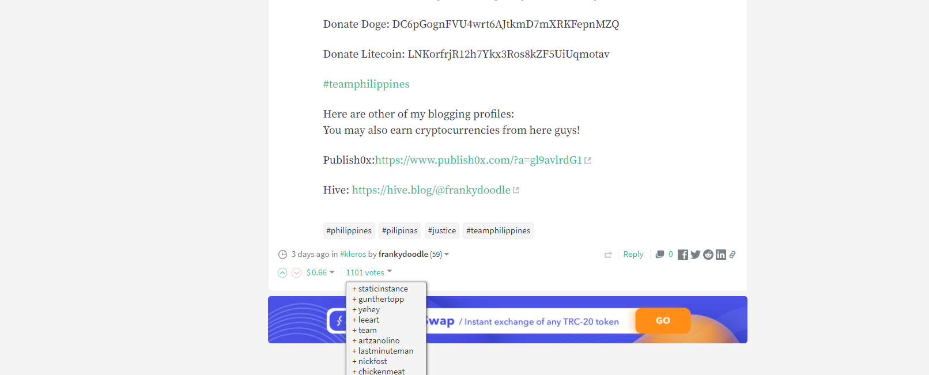
Fake accounts:
Gunteropp: https://steemit.com/@gunthertopp
Nickfrost (reported by other users for using a voting bot, no actual activity in several months): https://steemit.com/@nickfost and https://steemit.com/cat/@chekohler/re-nickfost-q6ej4h
Leeart (no blog/comment activity for 7 months): https://steemit.com/@leeart
Chickenmeat (no blog/comment activity for 7 months): https://steemit.com/@chickenmeat

