Honorable jury
My defense:
I want to argue in my defense that the same person who challengue me says "although it is not specified in the rules." With this it is clear that my case does not fall into a case of "violation of the rules" but rather a personal desire that challenges me.
My photo does not seek to violate any rule, it simply has a little shine so that my features are clear and at no time the opposite. I also want to attach evidence that on the same page of proof of humanity they place photos of models as "proof" as an example of the photos that must be uploaded, and all those photos have subtle editions, like the editions that are put on The models. Like my photo! Attach marked photos that have focus, contour and depth correction. I have knowledge of photography and what I did is not use any filter or alter the colors.
I also enclose the rules where it says that what is not allowed is "HEAVY MAKEUP" and I want to ask the jurors if when they see my photo, the first thing they really think is that I have a heavy make up. I think that If they vote "no" they should change all the rules and even the home page.
I am a strong believer in this technology and its power and I believe that decentralization is key! In this case we should respect the initial rules of the creators of the project in which I am not prohibited from what I did and not fulfill the request of a particular person! If we want to be free we should, as long as we respect the rules, let people choose how they want to show themselves
I hope common sense triumphs and thank you very much for allowing me to defend myself.

Considerations:
- I would like to invite the jury to be critical of the explicit rules and not in thoughts of "assumptions" of the challenger.
- If on the main page of the page they give us examples of photos well taken with slight retouching and this is legal, my photo has nothing but that it does not have any filter, it only has lighting. At no time alter the colors or use "heavy makeup"
- Attached the rules specified by the page
- The reasons argued by the challenger are all based on their assumptions and not on the strict rules that POH provides us
- The goal is to create a base of real people and I am a real person and I attach another photo to prove it
Nicolás Bassi
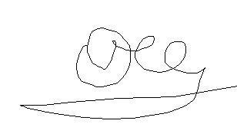
Evidence:

